Rockbuster Stealth
Data Dictionary.

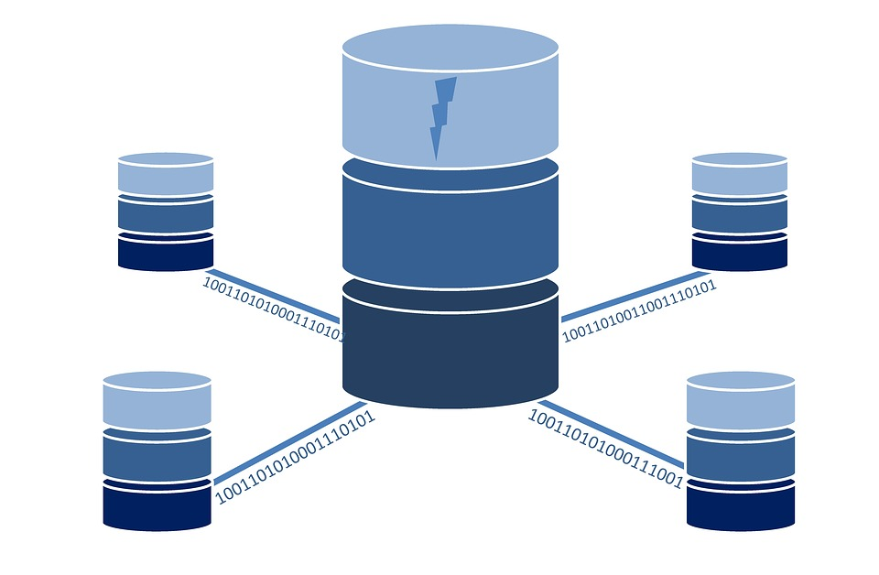

By Iusupov A.

Table of contents.

Entity relation diagram (ERD)…………………………………………………………………………………………………………………..3
Rental………………………………………………………………………………………………………………………………………………………4
Country……………………………………………………………………………………………………………………………………………………4
language…………………………………………………………………………………………………………………………………………….……4
inventory…………………………………………………………………………………………………………………………………………………5
film……………………………………………………………………………………………………………………………………………………….…5
City………………………………………………………………………………………………………………………………………………………….6
Customer…………………………………………………………………………………………………………………………….………………....6
Film actor………………………………………………………………………………………………………………………………………………..7
Store……………………………………………………………………………………………………………………………………………………….7
Address……………………………………………………………………………………………………………………………………………….….7
Actor……………….…………………………………………………………………………………………………………………………………..….8
Payment………………………………………………………………………………………………………………………………………………….8
Staff………………………………………………………………………………………………………………………………………………...…..…9
Category………………………………………………………………………………………………………………………………………………….9
Film category………………………………………………………………………………………………………………………………………….10

Entity Relational Data of the Rockbuster database.

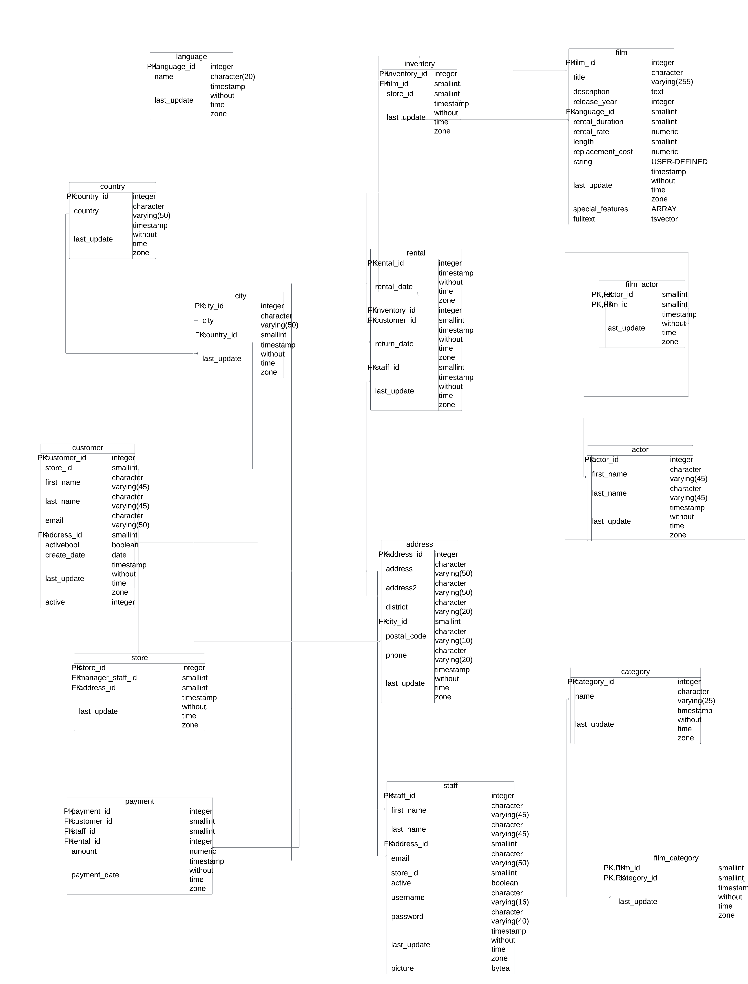

Table “rental” is fact table.
Columns | Data type | Description
rental_id | integer | Is a Primary Key. Gives a unique name/number for each record.
Rental_date | Timestampt without time zone | Gives information about the rental date.
Inventory_id | Integer | Is a foreign Key for the inventory table.
Cudtomer_id | Smallinteger | Is a foreign Key for the Customer Table.
Return_date | Timestamp without time zone | Give the information when the film had been returned.
Staff_id | Smallint | Is a foreign key to the staff table
Last_update | Timestamp without time zone | When was the last updated information inputed.

Table “country” is a dimension table.
Columns | Data type | Description
country_id | Integer | Is a Primary Key. Gives a unique name/number for each record.
country | Character varying (50) | Shows the country name.
Last update | Timestamp without time zone | When was the last updated information inputted.
Table “language” is a dimension table.
Columns | Data type | Description
language_id | integer | Is a Primary Key. Gives a unique name/number for each record.
name | Character (20) | Shows names. The length could be no more than 20 characters.
Last update | Timestamp without time zone | When was the last updated information inputted.

Table “inventory” is dimension table.
Columns | Data type | Description
inventory_id | integer | Is a Primary Key. Gives a unique name/number for each record.
film_id | smallint | Is a Foreign Key for the film table.
store_id | Smallint | Gives the store id code.
Last update | Timestamp without time zone | When was the last updated information inputted.

Table “film” is a dimension table.
Columns | Data type | Description
Film_id | Integer | Is a Primary Key. Gives a unique name/number for each record.
title | Chatacter varying (255) | Gives information about title of the film. It could be no more than 255 simbols.
description | Text | Shortly describe the plot of the movie.
Release_year | Integer | Production year.
Language_id | Smallint | Is a Foreign Key for the language table.
Rental_duration | smallint | How many days was the movie being rented.
Rental_rate | Numeric | Shows overall rate for rental.
Lengh | Smallint | Shows the duration of the movie.
Replacement_cost | Numeric | Shows the replacement amount.
Rating | User defined | MPAA. Motion picture association ratings. Shows rates like: PG (parents guided suggested), NC-17 (no one under 17 or under admitted), PG-13 (parent strongly cautioned), G (general audience), R (restricted)….
Last update | Timestamp without time zone | When was the last updated information inputted.
Special features | Array | Gives some extra features such as trailers, behind the Scene, or commentaries.
Full text | tsvector | Shows some information which I can not understand: “chamber” 1,” fate” 4, “husband” 11…

Table “city” is a dimension table.
Columns | Data type | Description
City_id | Integer | Is a Primary Key. Gives a unique name/number for each record.
City | Chatacter varying (50) | Shows the name of the city. No more than 50 simbols.
Country_id | Smallint | Is a Foreign Key for the country table.
Last update | Timestamp without time zone | When was the last updated information inputted.

Table “customer” is a dimension table.
Columns | Data type | Description
Customer_id | Integer | Is a Primary Key. Gives a unique name/number for each record.
Store_id | Smallint | shows information about store id.
First_name | Character varying (45) | Shows first name of customer
Last_name | Character varying (45) | Shows last name of customer
E_mail | Character varying (50) | Shows email of customer. No more than 50 simbols.
Address_id | smallint | Is a Foreign Key for the address table.
activebool | Boolean | Shows if customer active/not active by YES, NO or false, true methods.
Create_date | Date | Shows, when was the account created by customer.
Last update | Timestamp without time zone | When was the last updated information inputted.
Active | Integer | Didn’t understand this column. Maybe number 1 and 0 means yes or no?

Table “film_actor” is dimension table.
Columns | Data type | Description
Actor_id | smallint | Is a Primary Key. Gives a unique name/number for each record. Is a Foreign Key for the actor table as well.
Film_id | Smalint | Is a Primary Key. Gives a unique name/number for each record. Is a Foreign Key for the film table as well.
Last update | Timestamp without time zone | When was the last updated information inputted.

Table “store” is a dimension table.
Columns | Data type | Description
Store_id | Integer | Is a Primary Key. Gives a unique name/number for each record.
Manager_staff_id | Smallint | Is a Foreign Key for the staff table.
Address_id | smallint | Is a Foreign Key for the address table.
Last update | Timestamp without time zone | When was the last updated information inputted.
Table “address” is a dimension table.
Columns | Data type | Description
Address_id | integer | Is a Primary Key. Gives a unique name/number for each record.
Address | Character varying (50) | Shows the address of the customer.
Address2 | Character varying (50) | Shows additional address.
District | Character varying (20) | Shows district name.
City_id | Smallint | Is a Foreign Key for the city table.
Postal_code | Character varying (10) | Shows the postal code.
Phone | Character varying (20) | Shows customer’s phone number.
Last update | Timestamp without time zone | When was the last updated information inputted.

Table “actor” is a dimension table.
Columns | Data type | Description
Actor_id | integer | Is a Primary Key. Gives a unique name/number for each record.
First_name | Character varying (45) | Shows the first name
Last_name | Character varying (45) | Shows the last name
Last update | Timestamp without time zone | When was the last updated information inputted.

Table “payment” is a dimension table.
Columns | Data type | Description
Payment_id | integer | Is a Primary Key. Gives a unique name/number for each record.
Customer_id | Smallint | Is a Foreign Key for the customer table.
Stuff_id | Smallint | Is a Foreign Key for the stuff table.
Rental_id | integer | Is a Foreign Key for the rental table.
Amount | numeric | Shows the amount of payment.
Payment_date | Timestamp without time zone | Shows customer’s payment date.

Table “staff” is a dimension table.
Columns | Data type | Description
Staff_id | Integer | Is a Primary Key. Gives a unique name/number for each record.
First_name | Character varying (45) | Shows staff’s first name
Last_name | Character varying (45) | Shows staff’s last name
Address_id | Smallint | Is a Foreign Key for the address table.
Email | Character varying (50) | Shows emails of the staff.
Store_id | Smallint | Shows store id name/number.
Active | Boolean | Shows: yes/no or true/false
User_name | Character varying (16) | Shows user name of staff.
Password | Character varying (40) | Shows staff’s password.
Last update | Timestamp without time zone | When was the last updated information inputted.
Picture | Bytea | Shows staff’s picture.

Table “category” is a dimension table.
Columns | Data type | Description
Category_id | Integer | Is a Primary Key. Gives a unique name/number for each record.
name | Character varying (25) | Shows category: comedy, fiction, historical…
Last update | Timestamp without time zone | When was the last updated information inputted.

Table “film category” is a dimension table.
Columns | Data type | Description
Film_id | smallint | Is a Primary Key. Gives a unique name/number for each record. Is a Foreign Key for the film table as well.
Category_id | smallint | Is a Primary Key. Gives a unique name/number for each record. Is a Foreign Key for the category table as well. Shows unique number/code for the film.
Last update | Timestamp without time zone | When was the last updated information inputted.

